Mrs. Coes’ Grade Four Lesson Plans Week Two (Mon., April 20-Fri., April 24, 2020)

Day One
Part One: Numeracy
Outcome(s) N5: Describe and apply mental mathematics strategies to determine basic multiplication facts and related division facts to 9 × 9 N8: Demonstrate an understanding of fractions less than or equal to one N10: Relate decimals to fractions (to hundredths)

- Math Facts Practice: Sign in to Sum Dog and practice your math facts for 15 minutes!

- Fractions:
- Watch this video for a review of how to convert fractions to decimals https://www.youtube.com/watch?v=NlLjMc0EpZU
- Open the attached document called “fractions to decimals week 2 Day 1”. You can print the sheet or just write your answers on paper. Afterward, see how you did by comparing your work to the answer page that comes after the questions.

- Game Time!
- Consider making your own flash cards with the fraction and decimal on one side and a picture on the other. For example, on one side, draw a box divided into 10 equal parts and color 3 in. On the other side, write 3/10 and 0.3. Mix up the cards and then have someone show you the picture and you tell them what the fraction and decimal would be.
Part Two: Literacy
Outcome(s): GCO 4-Students will be expected to select, read, and view with understanding a range of literature, information, media, and visual texts. GCO 8- Students will be expected to use writing and other forms of representation to explore, clarify, and reflect on their thoughts, feelings, experiences, and learnings; and to use their imaginations.

- Let’s Read!
- Click https://classroommagazines.scholastic.com/support/learnathome/grades-3-5.html
- Select Week 2 and then scroll down to Day 6. Click to read the story called The amazing history of dogs.
- At the end of the articles you will find a link to watch the video "Into the World of Military Working Dogs." As you watch, make a list of all the ways dogs help soldiers.

- Let’s Write!
- After you have read the articles, imagine you could transform yourself into either a wolf or a dog. Which would you be? Write a paragraph explaining your choice and what time period you would like to live in. Find details in the articles, and use your imagination, to describe what your life would be like, what your daily activities might be, and what your relationship with humans would be like.

Day Two
Part One: Numeracy
Outcome(s) N5: Describe and apply mental mathematics strategies to determine basic multiplication facts and related division facts to 9 × 9 N8: Demonstrate an understanding of fractions less than or equal to one N10: Relate decimals to fractions (to hundredths)

- Math Facts Practice: Sign in to Sum Dog and practice your math facts for 15 minutes!

- Fractions!
- Watch this vide for a different explanation of how to convert fractions to decimals https://www.youtube.com/watch?v=yWcNQkmpYVk
- Open the attached document called “fractions to decimals week 2 Day 2”. You can print the sheet or just write your answers on paper. Afterward, see how you did by comparing your work to the answer page that comes after the questions.

- Game Time!
- Open the attachment called “Strike Out” and read about how to play the game. All you need is: pencil, paper and a deck of cards.

Part Two: Literacy
Outcome(s): GCO 4-Students will be expected to select, read, and view with understanding a range of literature, information, media, and visual texts. GCO 8- Students will be expected to use writing and other forms of representation to explore, clarify, and reflect on their thoughts, feelings, experiences, and learnings; and to use their imaginations.

- Let’s Read!
- Click https://classroommagazines.scholastic.com/support/learnathome/grades-3-5.html
- Select “Week 2” and then scroll down to “Day 7”.
- Click on “Cake Chemist” and scroll down to read the article OR click on “Text-to-Speech” on the left, for someone to read the article to you!

- Let’s Write!
- What science-inspired treats would you like to make for a themed party? Plan out 5 treats, thinking about what would make a spectacular cake, cupcake, or cookie. Draw what each treat would look like and describe how each treat would taste. Don't forget to give them each a name!

Day Three
Part One: Numeracy
Outcome(s) N5: Describe and apply mental mathematics strategies to determine basic multiplication facts and related division facts to 9 × 9 N8: Demonstrate an understanding of fractions less than or equal to one N10: Relate decimals to fractions (to hundredths)

- Math Facts Practice: Sign in to Sum Dog and practice your math facts for 15 minutes!

- Fractions!
- Watch this video to learn about comparing decimals https://www.youtube.com/watch?v=Za-QRAnarZM
- Open the attached document called “comparing decimals week 2 day 3”. You can print the sheet or just write your answers on paper. Afterward, see how you did by comparing your work to the answer page that comes after the questions.

- Game Time!
- Open the attachment called “Strike Out” and read about how to play the game. All you need is: pencil, paper and a deck of cards OR practice the flash cards you made on Day One.

Part Two: Literacy
Outcome(s): GCO 4-Students will be expected to select, read, and view with understanding a range of literature, information, media, and visual texts. GCO 8- Students will be expected to use writing and other forms of representation to explore, clarify, and reflect on their thoughts, feelings, experiences, and learnings; and to use their imaginations.

- Let’s Read!
- Click https://classroommagazines.scholastic.com/support/learnathome/grades-3-5.html
- Click Week 2, scroll down and select Day 8.
- Read the article called “Dolphins on duty” OR click on Text-to-Speech” on the left, for someone to read the article to you!

- Let’s Write!
- Imagine you're a dolphin spy on a secret mission for the Navy. Write a journal entry describing your daily tasks and activities. Use details from the article and the video "Discovering Dolphins" to make your entry realistic.
- What other type of animal would make for a good spy? Come up with a list of potential animal spies. Then choose one to research.

Day Four
Part One: Numeracy
Outcome(s) N5: Describe and apply mental mathematics strategies to determine basic multiplication facts and related division facts to 9 × 9 N8: Demonstrate an understanding of fractions less than or equal to one N10: Relate decimals to fractions (to hundredths)

- Math Facts Practice: Sign in to Sum Dog and practice your math facts for 15 minutes!

- Fractions
- Watch this new video about comparing fractions https://www.youtube.com/watch?v=GeHK8LD7AaM
- Open the attached document called “comparing decimals week 2 day 4”. You can print the sheet or just write your answers on paper. Afterward, see how you did by comparing your work to the answer page that comes after the questions.

- Game Time!
- Grab a deck of cards and a partner to play Addition or Subtraction War!

Part Two: Literacy
Outcome(s): GCO 4-Students will be expected to select, read, and view with understanding a range of literature, information, media, and visual texts. GCO 8- Students will be expected to use writing and other forms of representation to explore, clarify, and reflect on their thoughts, feelings, experiences, and learnings; and to use their imaginations.

- Let’s Read!
- Click https://classroommagazines.scholastic.com/support/learnathome/grades-3-5.html
- Find Week 2, scroll down and select Day 9 to read “Toxic Discoveries” to learn about the usefulness of snake venom!

- Let’s Write!
- Watch the video "Virtues of Venom". Make a T-chart that lists the ways venom can be harmful and the ways it can be helpful. Record yourself giving a speech about the uses of venom. Be sure to include information from both sides of your T-chart.
- It's Jenner and Undheim's job to work with venom. What else would you want to know about the study of venom? Write down 5 interview questions for Jenner and Undheim in your notebook.

Day Five
Part One: Numeracy
Outcome(s) N5: Describe and apply mental mathematics strategies to determine basic multiplication facts and related division facts to 9 × 9 N8: Demonstrate an understanding of fractions less than or equal to one N10: Relate decimals to fractions (to hundredths)

- Math Facts Practice: Sign in to Sum Dog and practice your math facts for 15 minutes!

- Fractions
- Watch this new video about ordering fractions https://www.youtube.com/watch?v=eDEUJ0xX5qQ
- Open the attached document called “ordering decimals week 2 day 5”. You can print the sheet or just write your answers on paper. Afterward, see how you did by comparing your work to the answer page that comes after the questions.

- Game Time!
- Game of your choice: War or Strike Out, or practice your flash cards with a partner.

Part Two: Literacy
Outcome(s): GCO 4-Students will be expected to select, read, and view with understanding a range of literature, information, media, and visual texts. GCO 8- Students will be expected to use writing and other forms of representation to explore, clarify, and reflect on their thoughts, feelings, experiences, and learnings; and to use their imaginations.

- Let’s Read!
- Click https://classroommagazines.scholastic.com/support/learnathome/grades-3-5-week-2.html
- Find Week 2, scroll down and select Day 10 to read “World’s Wildest Plants” to learn about five super cool plants OR click Text to Speech to hear someone read it to you.

- Let’s Write!
- Choose one of the five plants from the article that you are most interested in. Draw a detailed picture of the plant in your notebook. (You can also draw another plant that you see in your house or outside.) Make sure to label all of its parts, including its leaves, stems or branches, flowers, and roots. Then write a short description of what your plant looks like and how you think it stays alive.
- Watch the video "Incredible Plants." Then, plan and write a short comic strip from the point of view of a carnivorous plant trying to lure a fly into its trap. How will you introduce the plant and its habitat? What happens to the fly? Make your comic strip come alive with thought bubbles, scenery, and sound effects!
Science
This week you challenge is to create a magnetic maze! To do this you should take some time to watch the following video about magnetism: | I have also created a clip with quick instructions on how to do a magnetic maze:  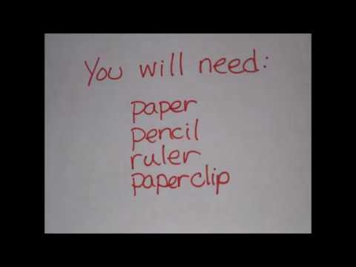

Physical Education
Physical Education is self directed at home but if you are looking for a couple of suggestions check out these!
Practice your throwing skills.  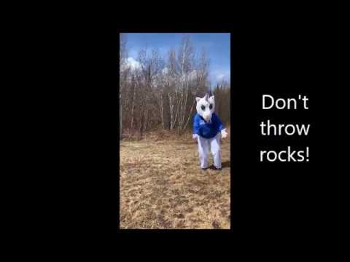 |  |  |  |  | Stuck inside? Why Not dance!
If you feel really comfortable with throwing and catching why not try learning to juggle? I will post a video later this week but for now try this video!
 |  |  | Weekly Challenge - Help out - Ask a parent if you can help make dinner or set the table.
Online resources:
https://scratch.mit.edu/ or www.code.org
- Students who wish to access their account can email alison.bush@nbed.nb.ca for their login and password.
https://musiclab.chromeexperiments.com/Song-Maker/ - Make some music. Share your links with Ms. Bush!

